Key Knowledge: Sound -Identify how sounds are made, associating some of them with something vibrating. -Recognise that vibrations from sounds travel through a medium to the ear. -Find patterns between the volume of a sound and the strength of the vibrations that produced it. -Recognise that sounds get fainter as the distance from the sound source increases.

**Knowledge Organiser**

**Year 4: Sound**

VOCABULARY

**vibration-** A movement backwards and forwards

**sound waves-** Vibrations travelling from a sound source.

**source**- The beginning: where something comes from.

**volume**- The loudness of a sound.

**amplitude**- The size of a vibration. A larger amplitude= a louder sound.

**pitch**- How high or low a sound is.

**ear**- An organ used for hearing.

**soundproof**- To prevent sound from passing.

**absorb sound**- To take in sound energy. Absorbent materials have the effect of muffling sound.

**eardrum-** Part of the ear, which is thick, tough layer of tissue that is stretched like a drum skin. Sound waves make the eardrum vibrate.

**sound**- a type of energy. Sounds are made when objects vibrate.

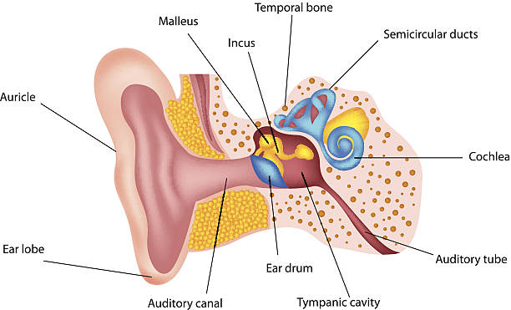**r**

The Ear

Sound Waves

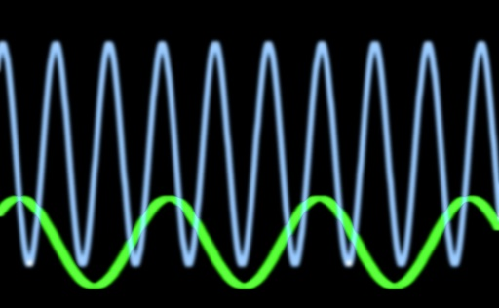nnh

Sound waves travel through solids, liquids and gasses.

Sounds are made when objects vibrate.

When an object vibrates, the air around it vibrates too. This vibrating air can also be known as sound waves. The sound waves travel to the ear and make the ear drums vibrate. Messages are sent to the brain which recognises the vibrations as sounds.

Sound waves and vibrations.

Sound waves carry energy from one place to another by moving the medium they travel through in a regular way. The waves move the medium as a series of **compressions** where the molecules move together and **rarefactions** where they are spread further apart. The energy travels in the same direction as the movement of the wave.

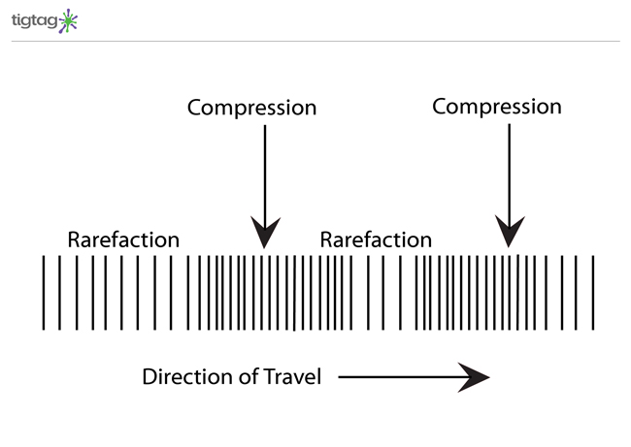





Year 4- Sound

Volume

Faster vibrations =higher pitch

The volume of a sound is how loud or quiet it is. When a sound is created by a little amount of energy, a weak sound wave is created which doesn’t travel far. This makes a quiet sound.

The closer you are to the source of the sound, the louder the sound will be. The further away you are from the sound, the quieter the sound will be.

Slower

vibrations =lower pitch

The frequency of a sound is measured in hertz (Hz).

This means the number of vibrations per second the particles are making as they transmit the sound.

Frequency

How musical instruments make different sounds.