North Walkden Primary School Knowledge Organiser
Subject: History | Term: Summer | Year Group: 1 | NC Link: changes within living memory. Where appropriate, these should be used to reveal aspects of change in national life
Mary Seacole was a nurse. Her mother was Jamaican and her father was Scottish. She travelled from Jamaica to look after wounded soldiers on the battlefield in the Crimean War. She set up a hospital called the British Hotel top look after soldiers.

Who Was Mary Seacole?
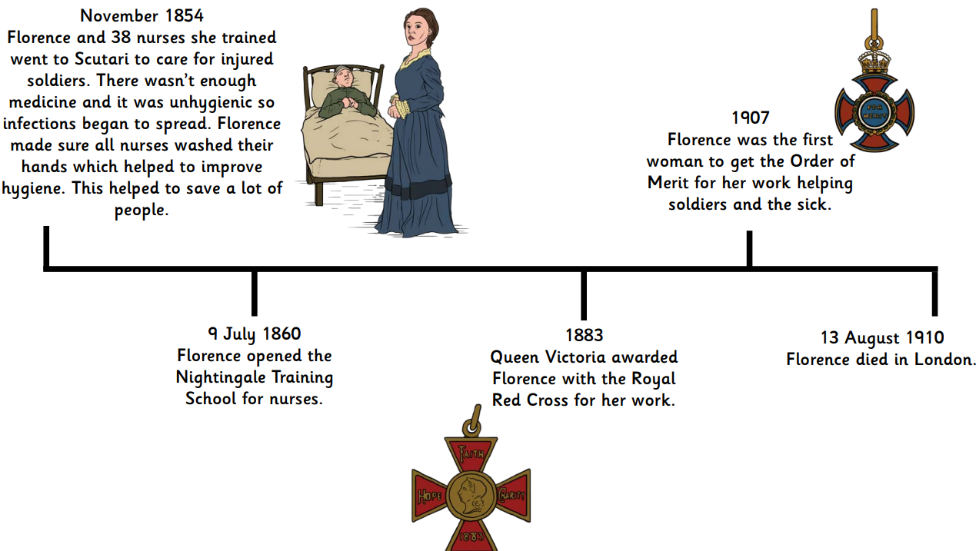
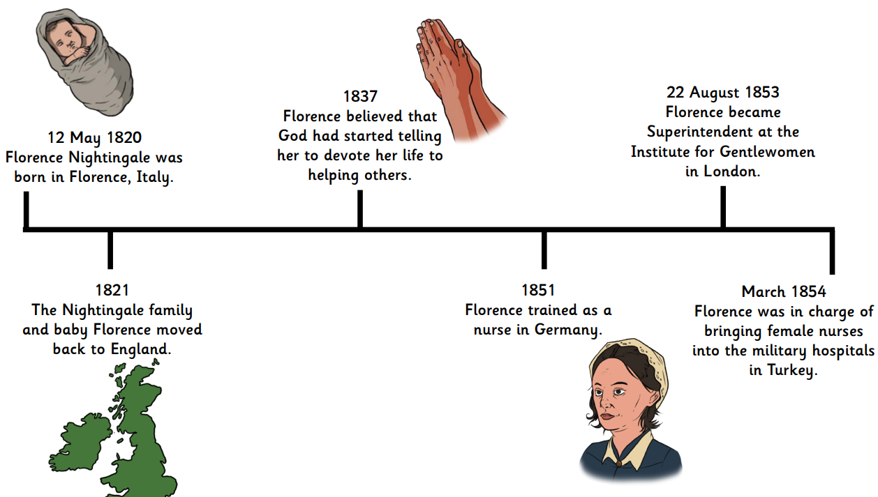
Florence Timeline

Glossary of Vocabulary
Infection – when a cut is not looked after and germs get inside your body and make you poorly
Antiseptic – a cleaning substance that can stop germs growing
Crimean war – a war which took place in Turkey from 1853 to 1856
Turkey – a country which lies in 2 continents: Europe and Asia
Achievements - something which you succeed in when you put in a lot of effort
Scutari hospital – the hospital in the Crimean War where Florence Nightingale and Mary Seacole worked

Florence and Mary
Florence Nightingale
1820-1910
Mary Seacole
1805-1881
Key Facts
Florence Nightingale and Mary Seacole were nurses who helped soldiers in the Crimean War during the Victorian Times.
Florence Nightingale improved nursing by making hospitals cleaner and showing kindness to her patients.
The Victorian Times were from 1837-1901. Florence Nightingale was born in 1820.
Florence Nightingale and Mary Seacole

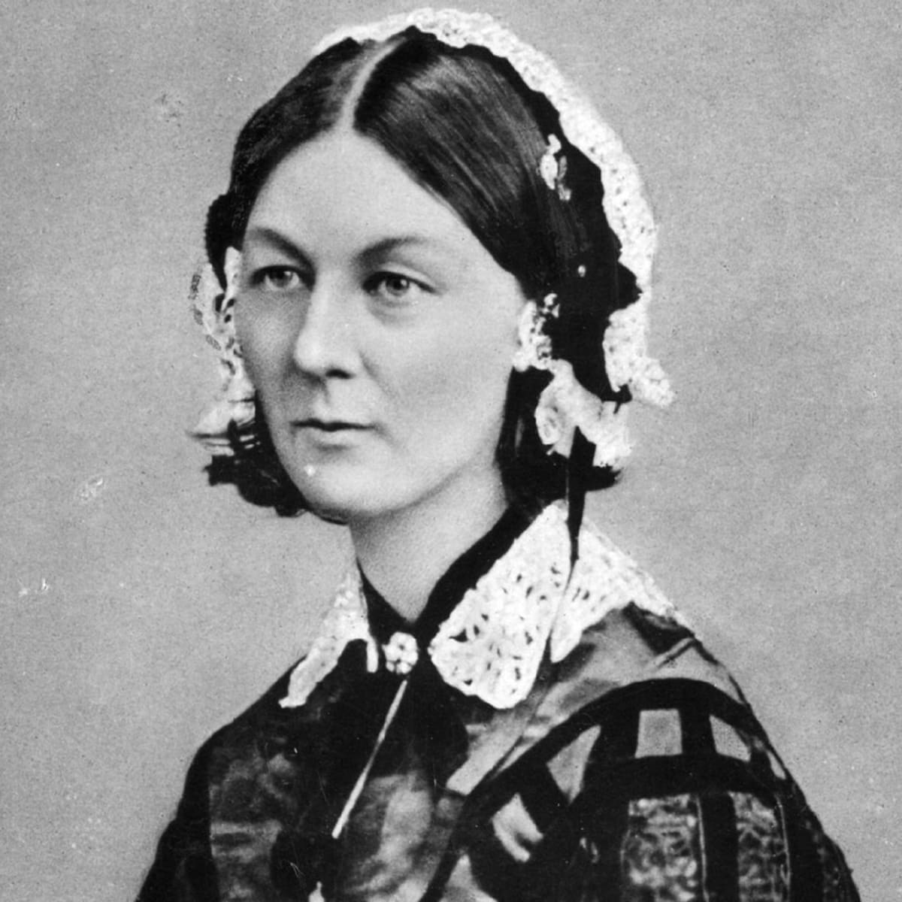
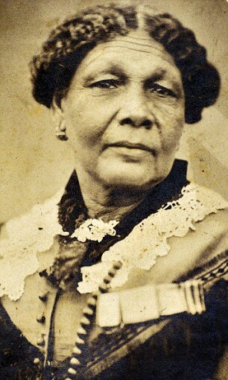
Prior Learning
Children have an understanding that life was different a long time ago. Children can recall some changes that have taken place within their living memory.

