Knowledge Organiser
Year 1
Seasonal Changes

The Seasons

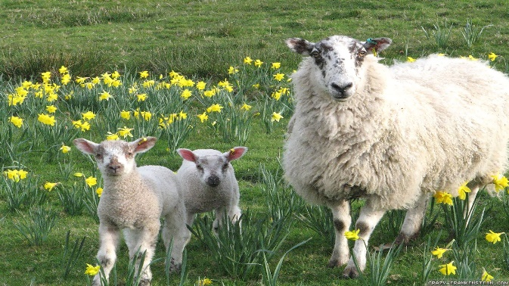
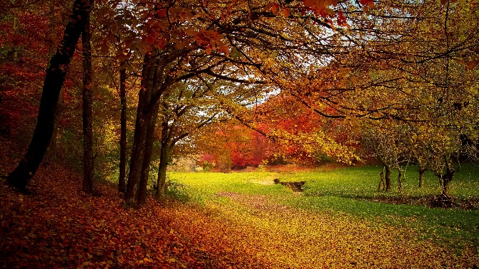
Spring
- March, April and May.
- Weather is warmer.
- Season of new beginnings.
- Fresh buds bloom, animals awaken. Farmers plant seeds.
- Approx. 12 hours daylight.

Autumn
- September, October, November.
- Weather is getting colder.
- Leaves start to fall from trees.
- Daytimes are shorter and nights are longer. 9-13 hrs of daylight.

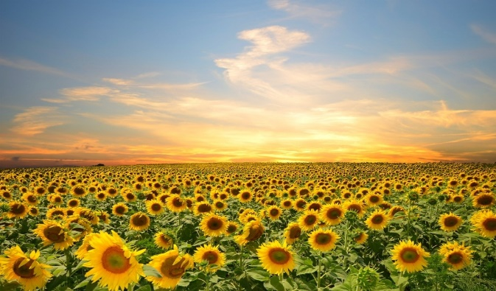
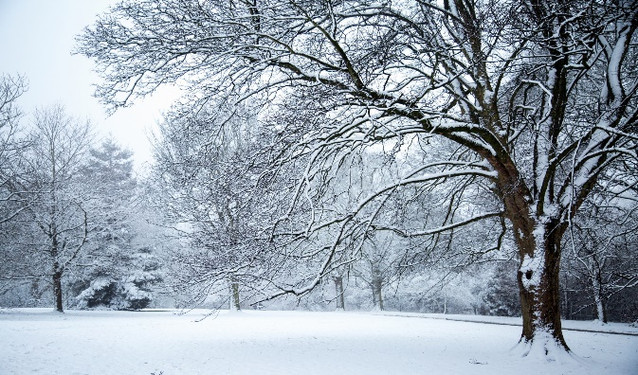
Summer
- June, July and August.
- The weather is much warmer.
- Warmest season of the year.
- Lots of leaves on trees.
- Approx. 16 hours of daylight
Winter
- December, January, February
- Weather is much colder and sometimes freezing.
- Can leave ice and frost on the ground.
- Many trees have bare branches.
- Daytimes are shortest and night times are longer. 8-10 hrs sunlight.

Season Vocabulary
Autumn- temperature starts to get colder
Winter- the coldest time of the year.
Spring- Weather starts to get warmer
Summer- Warmest time of the year
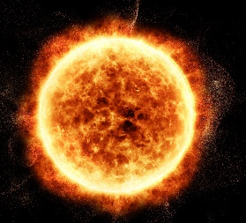
Sunny- when the sun shines and it is warm.
Rainy- when the weather is wet.
Windy- We can see windy weather by watching things blow about.
Snowy- when the water freezes and creates snow.
Day length- the number of hours it is light.
Sunrise- The start of the day, beginning to get light.
Sunset- The end of the day- beginning to get dark.







Working Scientifically: Asking simple questions and recognising that they can be answered in different ways. Observing closely, using simple equipment. Performing simple tests. Identifying and classifying. Using their observations and ideas to suggest answers to questions. Gathering and recording data to help in answering questions.

Collecting and recording data to make tables and charts about the weather. Make displays about what happens in the world around them, including day length as the seasons change.

Key Knowledge:
- To name four seasons and identify when in the year they occur.
- To observe and describe weather in different seasons.
- To describe days being longer in summer and shorter in winter.
- To present data in tables charts and compare seasons
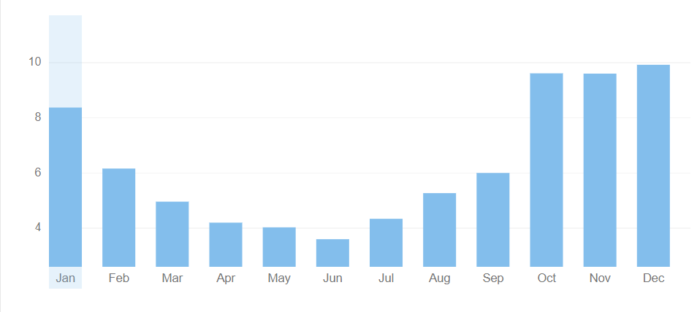
Weather

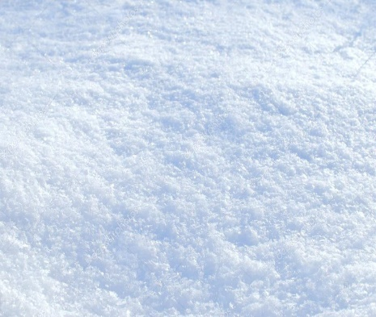

Snow

Rain
Snow is formed by water vapour in the air freezing before it turns to water. Clouds are cold and crystals are formed around bits of dirt and grow bigger.

Most rain falls in the Autumn/Winter (Sept-Jan). Spring has lots of rain downpours to help with growth.
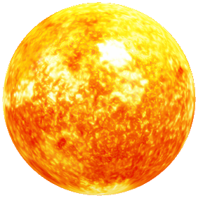

Sun
-The sun is a star
-It is a hot ball of glowing gas.
-At the heart of the solar system
-It is spherical in shape and much bigger than Earth- 1,350,000 times bigger!
-The temperature at the sun's core is about 27 million degrees Fahrenheit.

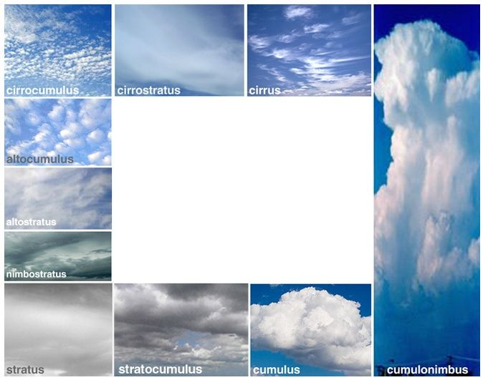

Clouds

A cloud is made of water drops or ice crystals floating in the sky. There are many kinds of clouds. Clouds are an important part of Earth's weather.




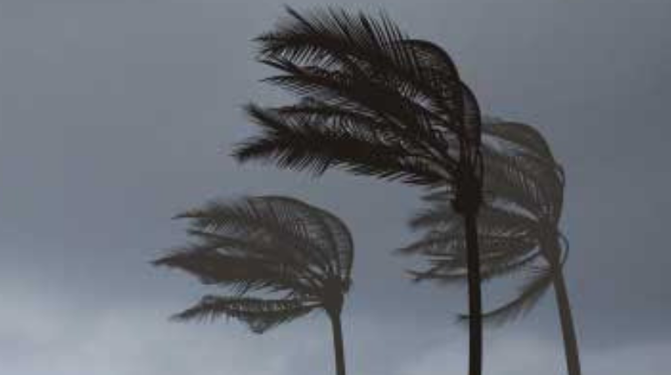

Wind
Moving air is called wind. Winds are created when there is a difference in air pressure.
You can see trees move and sway when it is windy.

Prior Learning
- Developing and understanding of change.
- Observe and explain why certain things may occur (e.g leaves falling off trees, weather changes).
- Look closely at similarities, differences, patterns and change.
Comments and questions about the place they live or the natural world.

