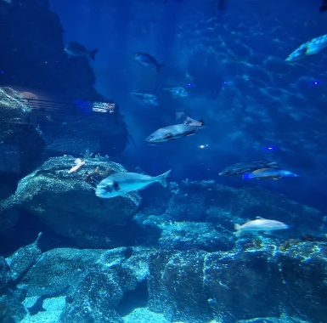
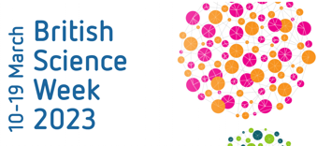

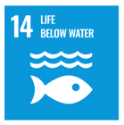

BSW: Life below water
Year 1

Our unit learning intentions | Pupil Self-reflection
LI: To name and identify common animals
LI: To name and identify common animals including marine life.
LI: To identify threats to marine life.
LI: To understand the properties and function of some underwater plants.
LI: To present my learning about life below water.

Our Scientific Enquiry Skills
  Comparative/Fair testing |   Research |   Observation over time |   Pattern seeking |   Identifying and classifiying
Our Working Scientifically Skills
  Questioning |   Prediction |   Setting up tests |   Observation and measurement |   Recording |   Interpreting results |   Evaluating

Vocabulary

sea | fish | seaweed | algae
animals | environment | sustainability | fishing
pollution | marine | plants | population

