Knowledge Organiser
Year 1: Plants

- Key Knowledge: Name common plants and describe the basic structure of flowering plants, including deciduous and evergreen.
- Identify and describe the basic structure of a variety of common flowering plants, including trees.

VOCABULARY
plant- a living thing that usually grows from the ground.
flower- The part of a plant that blossoms.
leaves- use light, air and water to make food for the plant.
stem- Carries water and nutrients to different parts of the plant.
roots- Holds the plant in the ground and absorbs water and nutrients from the soil.
seed- production of flowering plant, develops into another plant.
bulb- round storage system in some plants e.g lily, daffodil.
bud- compact growth on a plant which develops into a leaf, flower or shoot.
blossom- a flower or mass of flowers on a tree or bush.

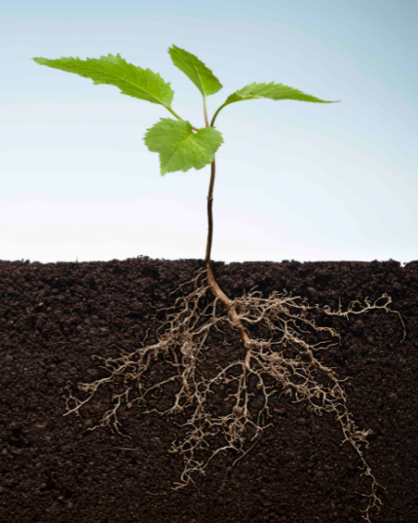
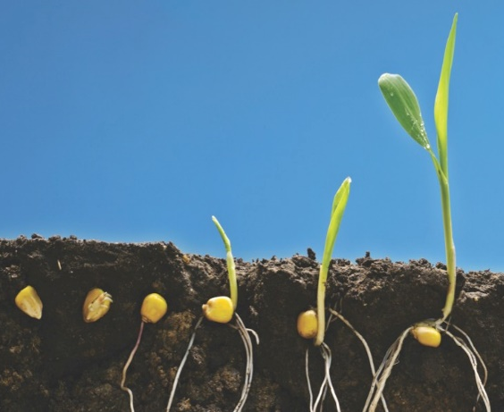
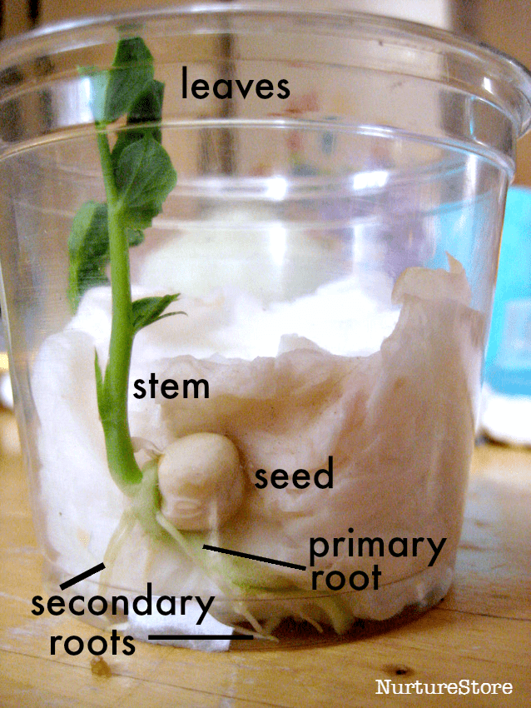
leaves
leaves
stem
stem
root
seed
roots

Conditions for growth
Seeds and bulbs
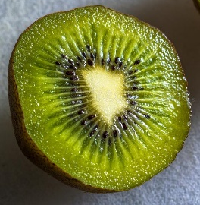
Rain/water
Sunlight
Temperature
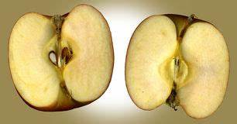
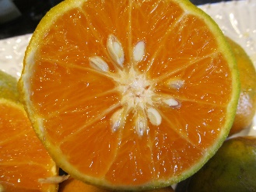
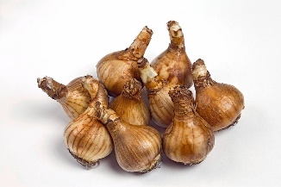


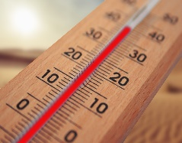

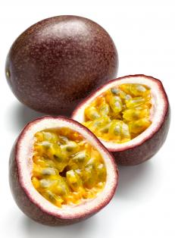


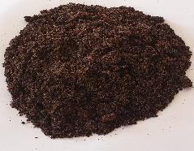
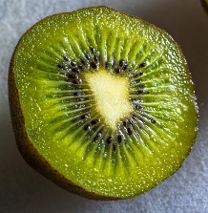
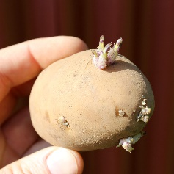
Seeds come in all shapes and sizes and can be found in fruits and vegetables.

Air
Time
Nutrients








Working Scientifically

Prior Learning : (EYFS) Natural world: Explore the world around them making observations and drawings of plants. Know some similarities and differences between the natural world around them and contrasting environments, drawing on their experiences and what has been read in class. Communication and language- express their ideas and feelings about their experiences using full sentences.

Parts of a flower
Common Flowers
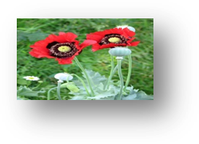
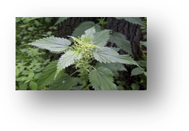
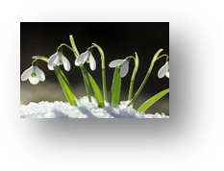




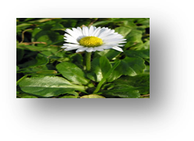
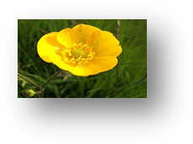
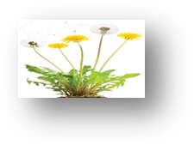
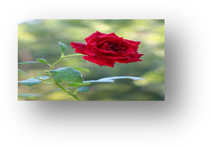
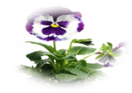
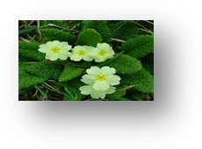
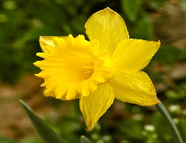
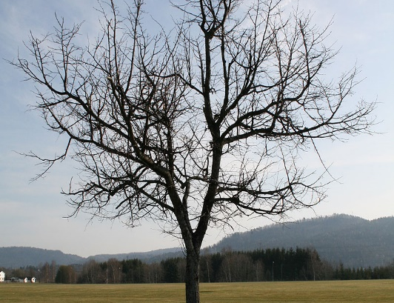
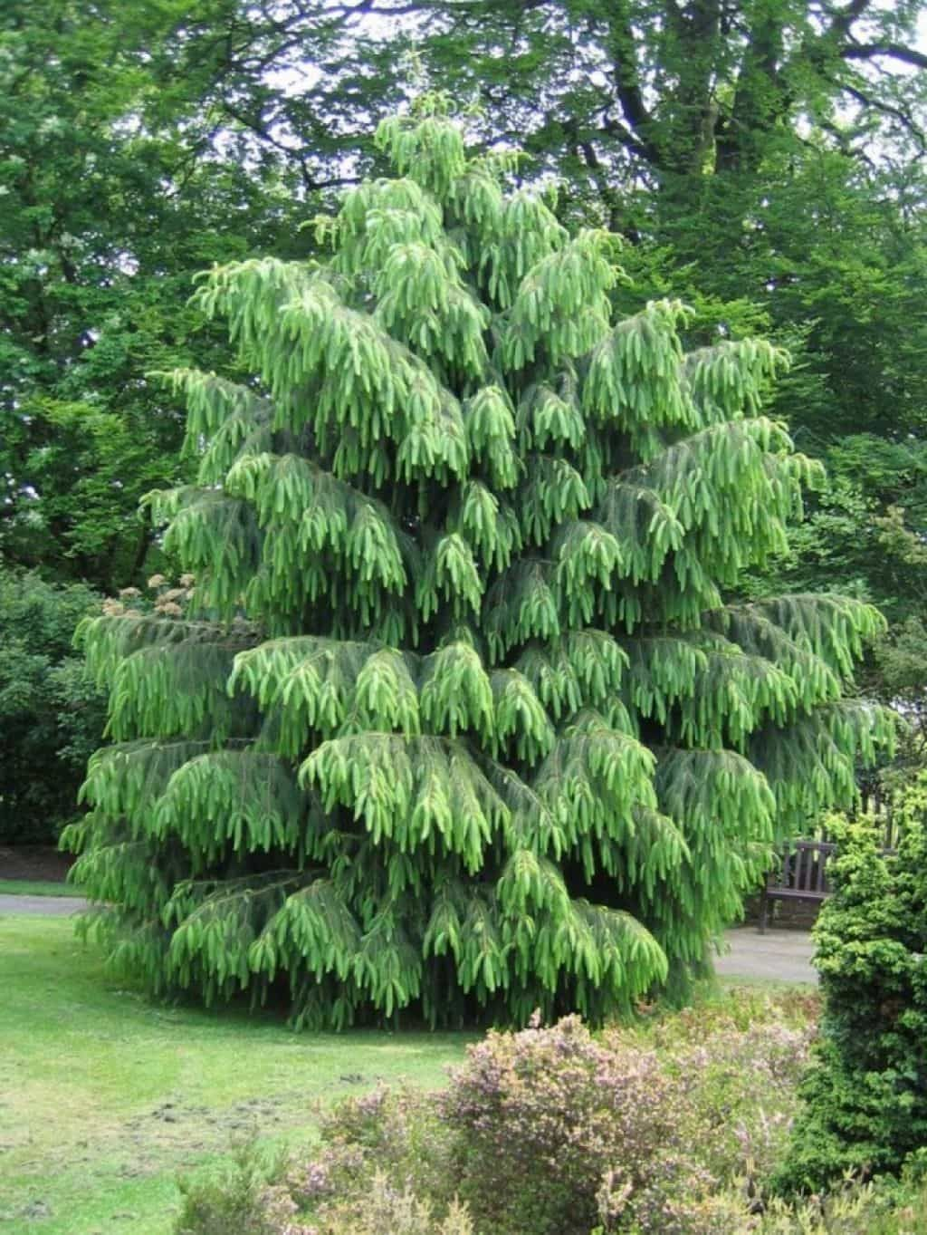
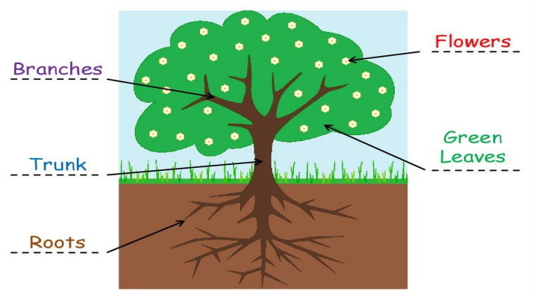
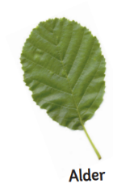
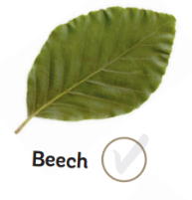
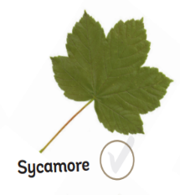
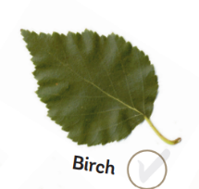
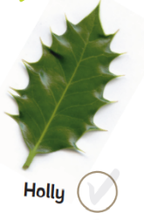

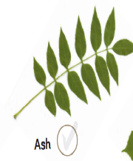
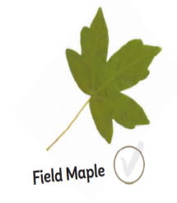
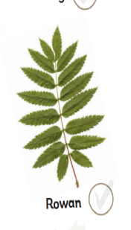
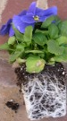
Evergreen/deciduous trees
Types of leaves
Evergreen
Deciduous
Structure of a tree
Scientific Enquiry
Petals/Flower
Leaves
Roots
Poppy
daisy
Stinging Nettle
rose
Snowdrop
pansy
Primrose
daffodil
Buttercup
dandelion
Keeps leaves all year round e.g. pine, cedar, Holly, fir.
Shed their leaves annually e.g. Oak, Maple, Hawthorn, Sycamore, Beech and Elm.

