Knowledge Organiser-Year 2 Materials
Key Knowledge: Can name an object, say what material it is made from, identify properties and make a link between property and use. Whilst changing a shape of an object can describe the actions used. Can use suitable vocabulary. Simple tests relevant to properties. Describe similarities and differences.

Properties of materials.
Changing materials

 | WOOD  Hard, stiff, strong, opaque, can be carved or formed into any shape. | 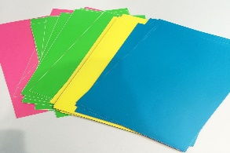 | PAPER  Lightweight, flexible, can be coloured and come in different forms.
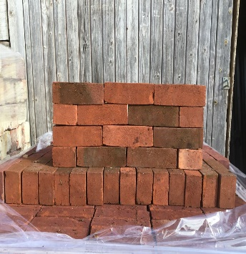 | BRICK  Strong, stiff, opaque, structural, can be solid or hollow. Vary in size and colour. | 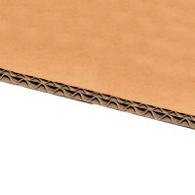 | CARDBOARD  Durable, strong, light, stiff. Can be moulded and bent easily.
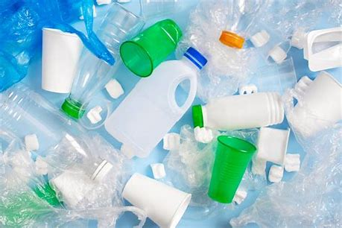 | PLASTIC  Waterproof, strong, can be made to be flexible or stiff, smooth or rough. |  | FABRIC  Soft, flexible, hard-wearing, can be stretchy, warm and absorbent.
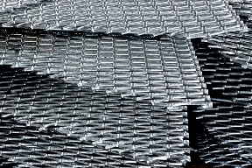 | METAL  Strong, hard, easy to wash, can be melted and moulded, generally shiny. | 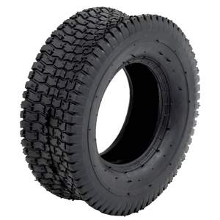 | RUBBER  Hard-wearing, elastic, flexible, strong, bouncy, strong.
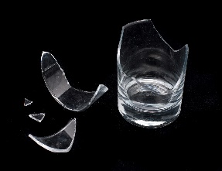 | GLASS  Waterproof, transparent, hard, smooth, fragile, can be heated to change shape. | 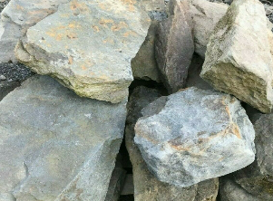 | STONE  Strong, used for building, comes in different forms.

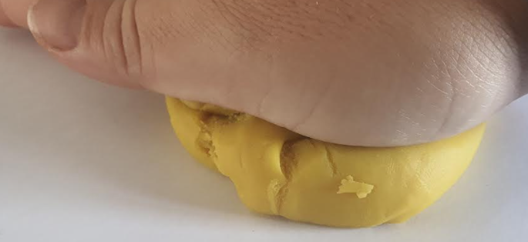  SQUASH  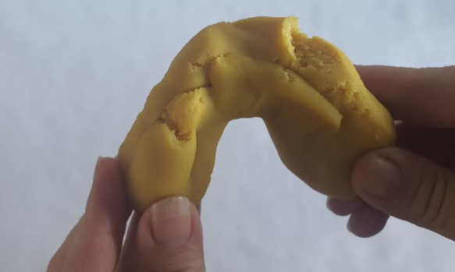 | Crush or squeeze with a force so that it becomes flat or a different shape.
BEND | Shape or force something into a curve or angle.
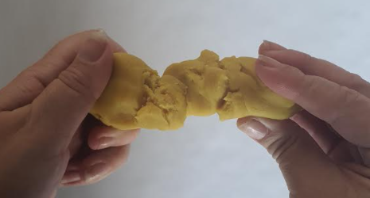  TWIST | Rotate, twisting around a stationary point making a spiral shape.
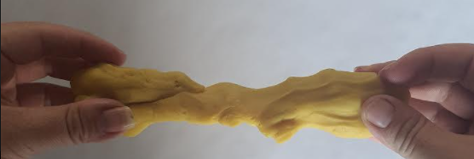  STRETCH  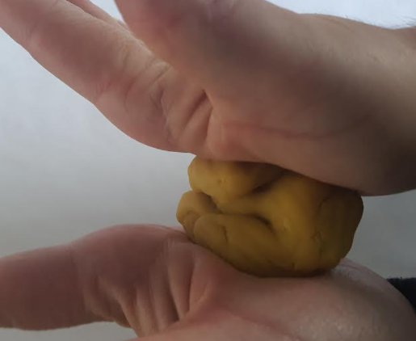 | By pulling to make something longer.
PUSH | Place a force in order to move something away.
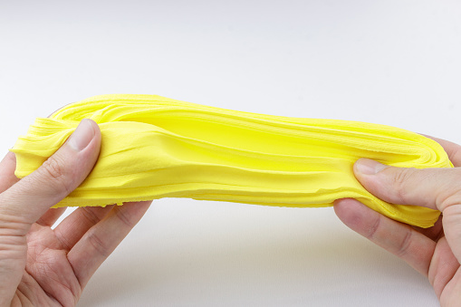  PULL  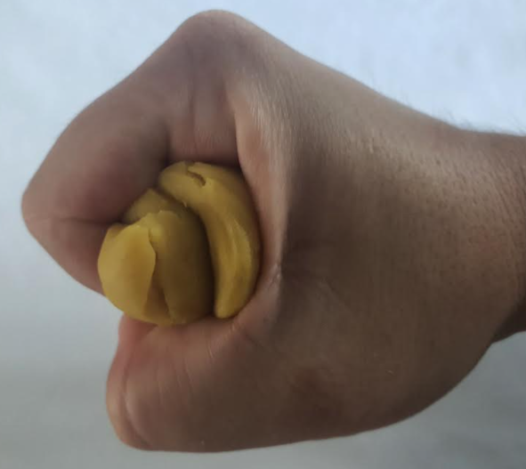 | Place a force to cause a movement towards something.
SQUEEZE | Firmly press or force something through a narrow space.






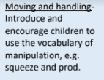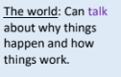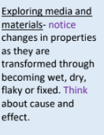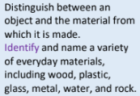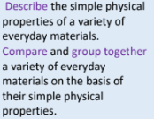

Prior Knowledge

VOCABULARY
materials- what objects are made from.
suitability- having the right properties for purpose.
properties- What a material is like and how it behaves.
waterproof- keeps water out.
shock absorbent- absorbing energy to sudden shocks/impact.
reflective- to reflect light.

Famous Scientists (Science Capital)

JOHN
MCADAM
1756-1836
Scottish engineer who experimented with using new materials to build roads, inventing a new process called ‘macadamisation’. His effective and economical method of constructing roads is used across the world.

JOHN DUNLOP
1840-1921
Scottish engineer and veterinary surgeon. Made rubber devices and invented the pneumatic tyre, developed the use of them in cycle racing.

CHARLES MACINTOSH
1766-1843
macadamisation’.
Scottish chemist and inventor of waterproof fabric. His process involved painting a dissolved rubber solution into cloth. The Macintosh raincoat is named after him.

