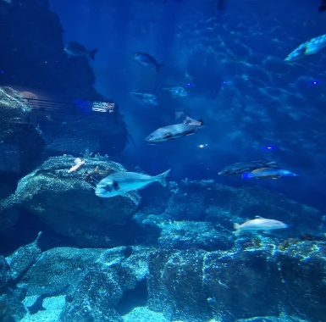


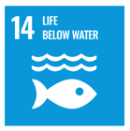

Unit: Life below water
Year 2: Spring 2 (R*Y1)

Our unit learning intentions | Pupil Self-reflection
To name and identify common animals
To name and identify common animals including marine life.
To identify threats to marine life.
To understand the properties and function of some underwater plants.
To present my learning about life below water.

Our Scientific Enquiry Skills
  Comparative/Fair testing |   Research |   Observation over time |   Pattern seeking |   Identifying and classifiying
Our Working Scientifically Skills
  Questioning |   Prediction |   Setting up tests |   Observation and measurement |   Recording |   Interpreting results |   Evaluating

Vocabulary
sea | fish | seaweed | algae
animals | environment | sustainability | fishing
pollution | marine | plants | population

To name and identify common animals.

To name and identify common animals including marine life.

To identify threats to marine life.

To understand the properties and function of some underwater plants.

To present my learning about life below water.
sea fish

seaweed

algae

animals

environment
sustainability
fishing

pollution
marine

plants

population

