Knowledge Organiser-
Year 2 Plants
Key Knowledge: To observe and describe how seeds and bulbs grow into mature plants. Find and describe how plants need water, light and a suitable temperature to grow and stay healthy

VOCABULARY
plant- a living thing that usually grows from the ground.
flower- The part of a plant that blossoms.
leaves- use light, air and water to make food for the plant.
stem- Carries water and nutrients to different parts of the plant.
roots- Holds the plant in the ground and absorbs water and nutrients from the soil.
seed- production of flowering plant, develops into another plant.
bulb- round storage system in some plants e.g lily, daffodil.
bud- compact growth on a plant which develops into a leaf, flower or shoot.

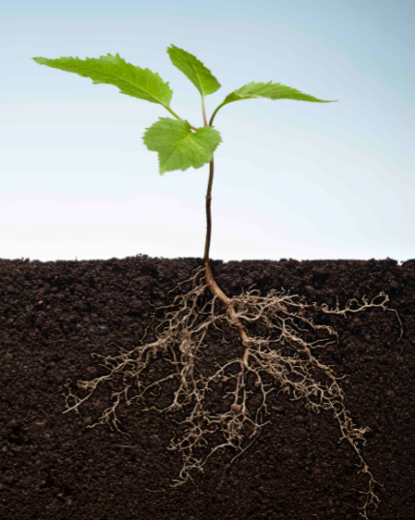
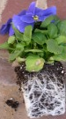
Leaves
Petals/Flower
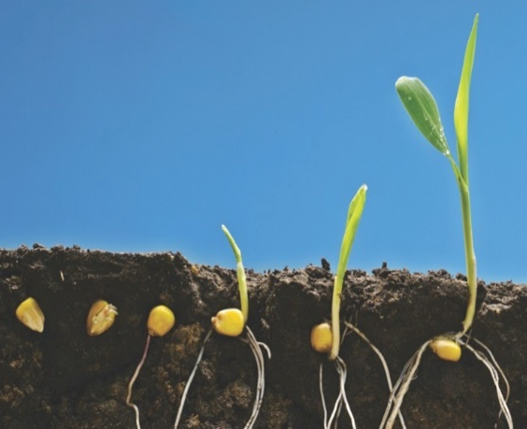
Leaves
Stem
Leaves
Stem
Seed
Root
Roots
Roots

Conditions for growth

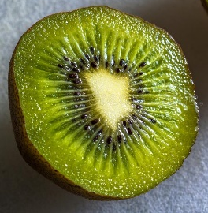
Rain/water
Sunlight
Temperature


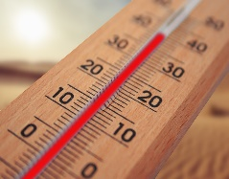
Seeds and bulbs

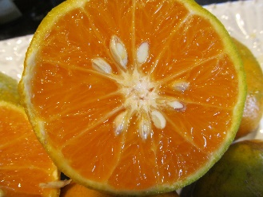
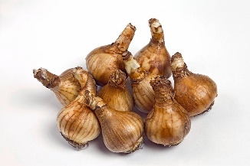
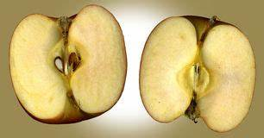

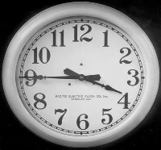
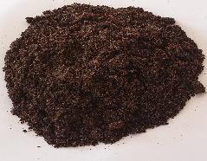

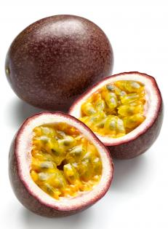
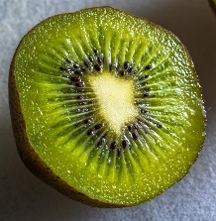
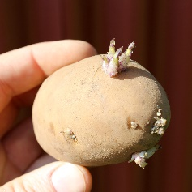
Seeds come in all shapes and sizes and can be found in fruits and vegetables.
Air
Time
Nutrients
Working Scientifically








Previous Learning: (Year 1 ) Name common plants and describe the basic structure of flowering plants, including deciduous and evergreen. Identify and describe the basic structure of a variety of common flowering plants, including trees.





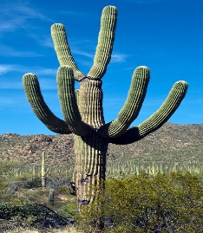
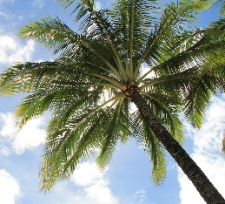
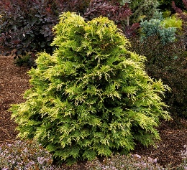
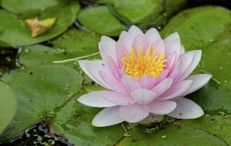
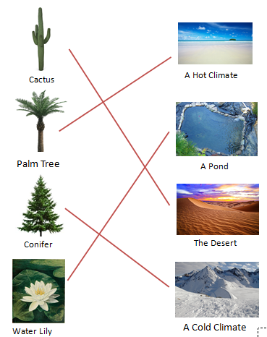
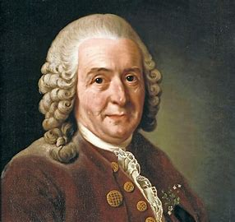
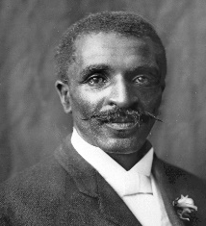
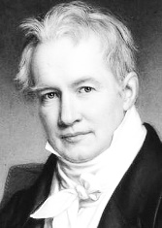


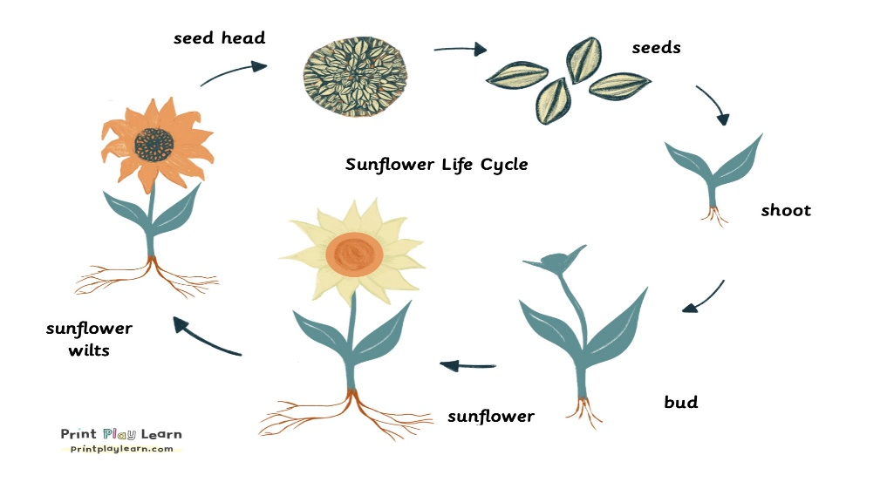
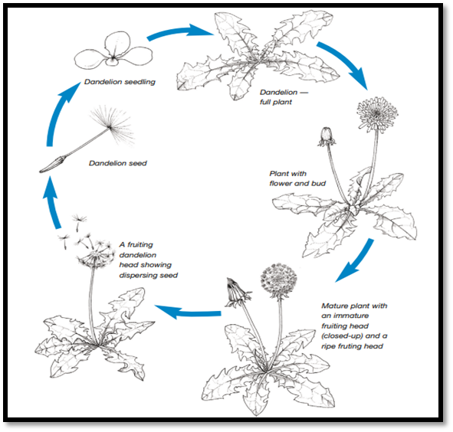
Lifecycle of a sunflower
Plants in different climates
Famous botanists.
Carl
Linnaeus
George Washington Carver
Alexander Von Humboldt
Oliver Rackham
Dr Angie Burnett.
Plants adapt to their environment and climate.
Scientific Enquiry

