Knowledge Organiser-Year 3: Rocks
Prior Learning: May have some understanding of a variety of different rocks in the natural world. Some understanding of what soil is. (how to identify soil etc). May have some knowledge of what a fossil is.
May have some knowledge of what a fossil is.
Knowledge Organiser Year 3: Rocks

r
The Rock Cycle.
VOCABULARY
fossil- the remains or impression of a prehistoric plant or animal embedded in rock and preserved in petrified form.
magma- molten rock that remains underground.
lava- Molten rock that comes out of the ground is called lava.
sediment- Natural solid material that is broken down by processes of weathering, erosion and transported by the action of wind, water or ice or by the force of gravity acting on it.
permeable- Allows liquid to pass through.
impermeable- Does not allow liquids to pass through.
durable- withstand pressure, damage or hard wearing.
acidity- the level of acid in substances.

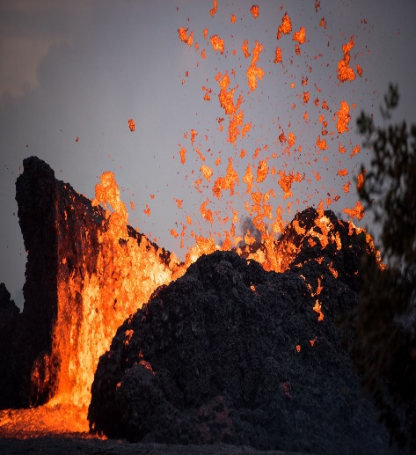
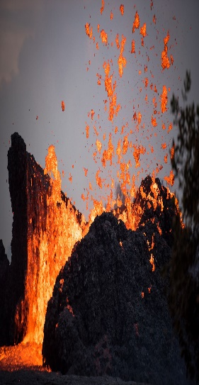
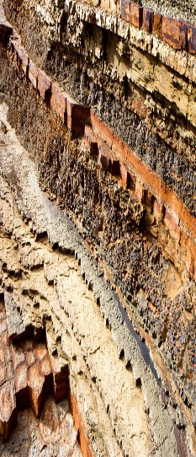
nnh
IGNEOUS ROCK
Rock that has been formed from magma or lava.
Examples: obsidian, granite, basalt

METAMORPHIC ROCK
Rock that started out as igneous or sedimentary but changed due to being exposed to extreme heat or pressure.
Example: Marble, Quartzite, Slate.

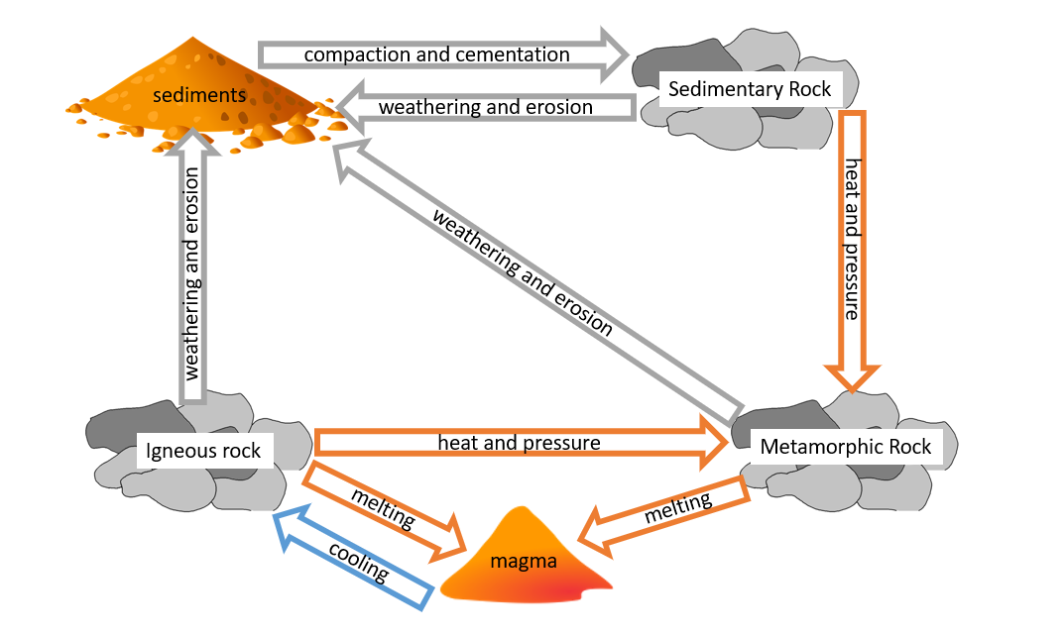

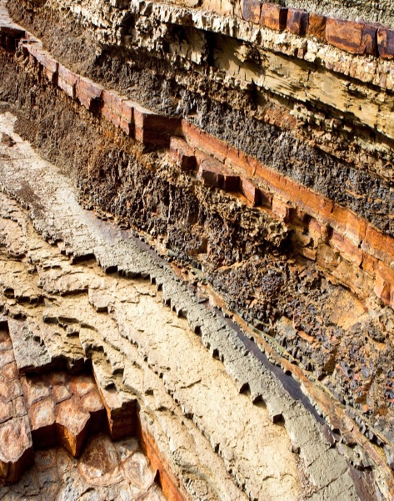
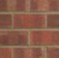
SEDIMENTARY ROCK
Rock that has been formed by layers of sediment being pressed down hard and sticking together. You will see layers in the rock.
Example: chalk, sandstone, limestone.

HUMAN_MADE ROCK
(Anthropic Rocks)

Rocks made or modified by humans. The Romans first invented concrete.
Example: Brick, Concrete, Coade Stone.









Key Knowledge: To name some types of rock and give physical features of each. To explain how a fossil is formed. To explain that soils are made from rocks and also contain living/dead matter. To be able to classify rocks in a range of ways using scientific vocabulary. To test properties of rocks. To show understanding of how fossils were formed, can identify plant/animal matter in soil, test water retention of soils.

The Process of Fossilisation.

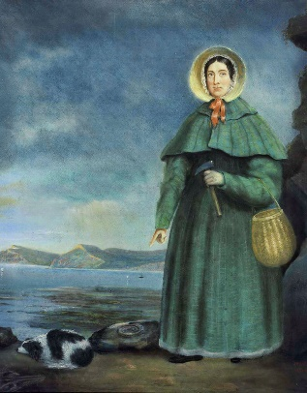
Mary Anning (1799-1847)
English fossil collector who became known around the world for finds she made in Jurassic marine fossil beds located in Lyme Regis. She correctly identified the ichthyosaur when she was 12 years old. She was known as ‘Mary Anning, The Fossil Finder’.
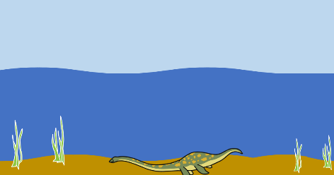  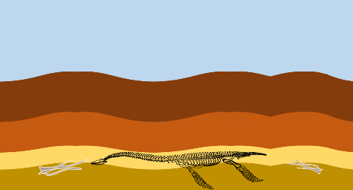 | An animal dies. It gets covered in sediment. After a while the animal will rot leaving behind only the bones (skeleton).
 | Layers of rock cover the skeleton.
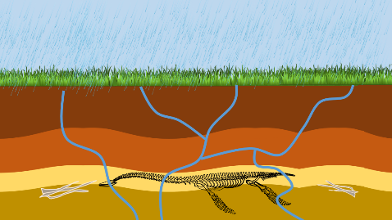 | Over thousands of years pressure forces the sedimentary layers together, turning them into sedimentary rock. Sediment enters the mould to make a cast fossil.
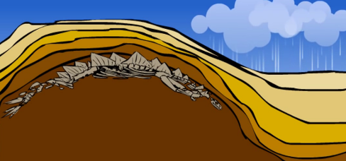 | The water transports tiny pieces of impermeable rock, which are left inside the mould. Over time the whole skeleton or remains will become solid rock- called a cast
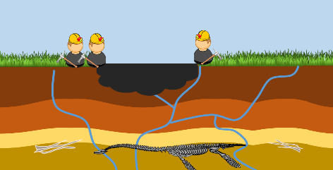 | As erosion and weathering take place, eventually the fossil becomes exposed. Scientists called palaeontologists examine bones to find out about animals.

Soil

Soil is the uppermost layer of the Earth. It is a mixture of different things:

-Minerals
-Air
-Water
-Organic matter (including living and dead plants and animals)
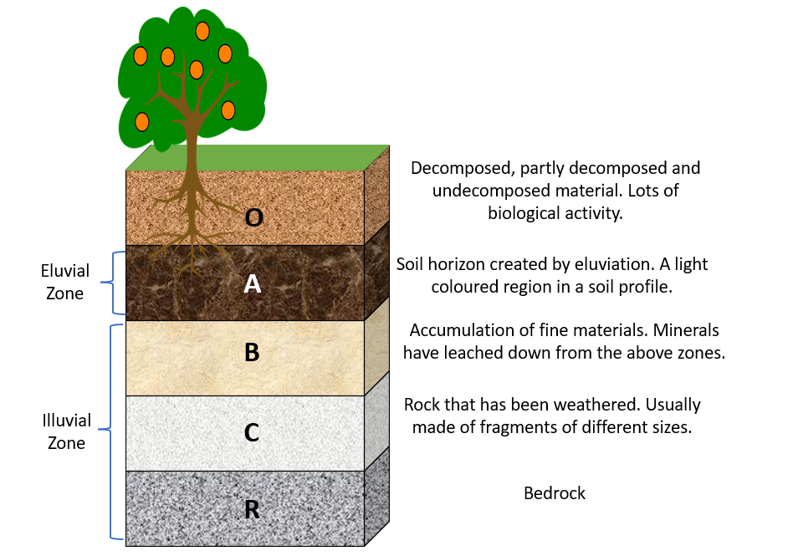




Working Scientifically: Ask relevant questions and use different scientific enquiries. Make systematic and careful observations, take accurate measurements using standard units, use a range of equipment. Gather, record, classify and present data in a variety of ways to help in answering questions. Record findings using simple scientific language, drawings, labelled diagrams, bar charts and tables.
Report on findings from enquiries including oral and written explanations.
Use results to draw simple conclusions, suggest improvements and raise further questions.
Identify similarities and differences.
Use straightforward scientific evidence to answer questions or to support their findings

