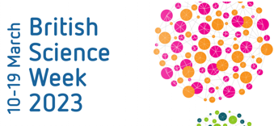
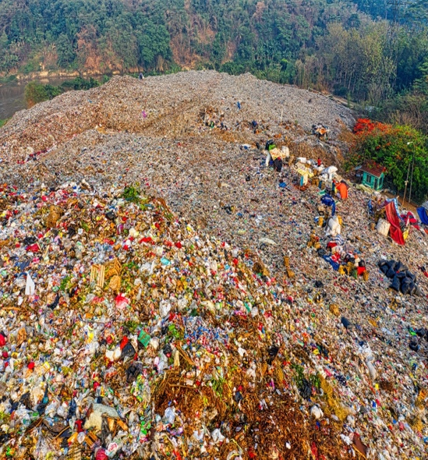


BSW: Climate Action
Year 3

Our unit learning intentions | Pupil Self-reflection
LI: To know which materials we can reduce, reuse and recycle to be more sustainable
LI: To explain what happens to our rubbish when we put it in the bin
LI: To recognise that soil is made from rock and organic matter
LI: To explore a plants requirement for life and growth

LI: To use my knowledge to present an argument
Our Scientific Enquiry Skills
  Comparative/Fair testing |   Research |   Observation over time |   Pattern seeking |   Identifying and classifiying
Our Working Scientifically Skills
  Questioning |   Prediction |   Setting up tests |   Observation and measurement |   Recording |   Interpreting results |   Evaluating

Vocabuary | reduce | recycle
Vocabuary | drought | recover
reuse | compost | climate change

