Knowledge Organiser- Year 3
Animals Including Humans

Working Scientifically: Asking relevant questions and using different types of scientific enquiry to answer them. Setting up simple practical enquiries, comparative, and fair tests. Making systematic and careful observations and, where appropriate, taking accurate measurements using standard units, using a range of equipment, including thermometers and data loggers. Gathering, recording, classifying, and presenting data in a variety of ways to help in answering questions.
- Record findings using simple scientific language, drawings, labelled diagrams, keys, bar charts and tables.

VOCABULARY
vertebrate- An animal with a backbone inside their body.
bones- The hard parts inside your body which form your skeleton.
skeleton- The framework of bones in your body.
backbone (Spine) The column of small, linked bones down the middle of your back.
muscle- move the different parts of your body, inside and out.
healthy- feeling well and not suffering any illness.
exercise- a physical activity to keep your body fit.
hygiene- how clean something is.
disease- an illness which affects people, animals or plants.
bacteria or virus.
balanced diet- Choosing foods in the right amounts from each of the food groups.

What do we need to survive and be healthy?
Key Knowledge
-To name the nutrients found in food.
-To state that to be healthy we need to eat the right types of food to give us the correct amount of these nutrients.
-Name some bones that make up the skeleton giving examples that support, help them move or provide protection.

-To describe how muscles and joints help them to move. Classify food groups (high/low nutrients), answer about nutrients in food, use data to look for patterns. Give similarities and differences between skeletons.

Balanced diet Water Air Exercise Hygiene
(Food)
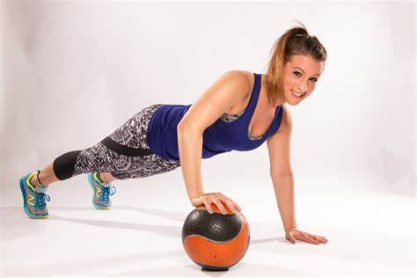
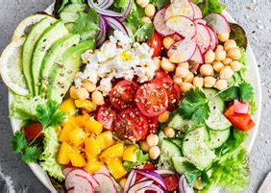


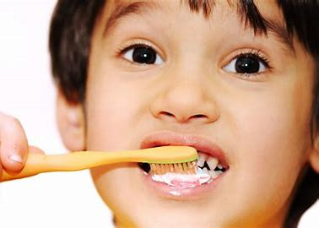

Skeleton
All mammals (including humas), birds, fish, reptiles and amphibians are vertebrates. This means they have a skeleton inside their bodies.
The human skeleton is made of bones and grows as we grow. Our skull protects our brain and our ribs protect our heart and lungs.
The skeleton bends at joints such as knees and ankles. Joints are where two or more bones join together.

The Skeletal System.
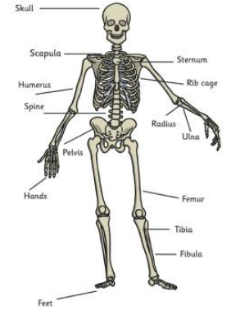


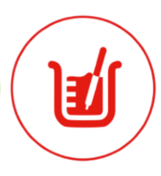


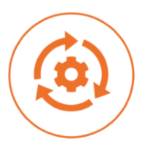



Year 3
Animals Including Humans
Three types of skeleton.






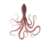
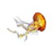
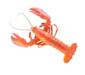
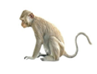
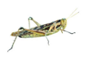
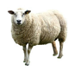
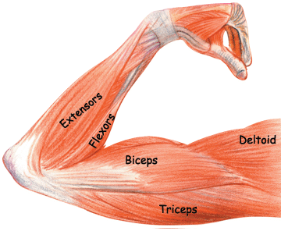
Pectorals
Biceps
Abdominals
Quadriceps
Triceps
(back)
Hamstring
(back)
Calves
(back)
A Balanced Diet
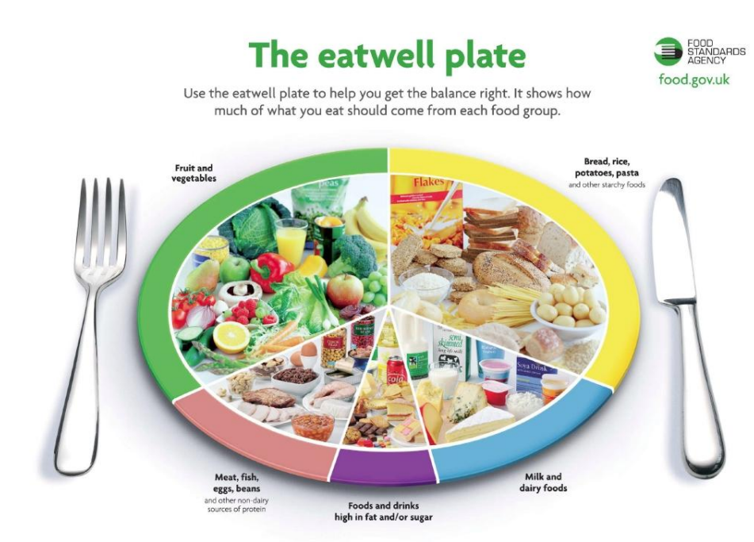

Muscles
- Your body has over 650 muscles and may different types of joints to allow your bodies to move in different ways.
- They are attached to the skeleton to help us move. They either contract (bunch up) or relax (go back to normal) to move the bones.
- It takes 17 muscles to smile
- It takes 43 muscles to frown!
Our arm muscles
Drink plenty of water.
Carbohydrates give us energy.
Proteins help our bodies repair themselves.
Fats help store energy for our bodies.
Fibre is important for helping us digest our food.
Nutrition
Nutrition means getting the food they need to grow and be healthy.

Endoskeleton
Exoskeleton
Hydrostatic skeleton

Skeleton inside the body. As the animal grows so does the skeleton.
Skeleton is on the outside. They shed their skeleton. Skeleton does not grow with the animal, so it sheds it and grows a new one.
The skeleton does not consist of bones. They are all invertebrates. They have fluid filled compartments in their body.
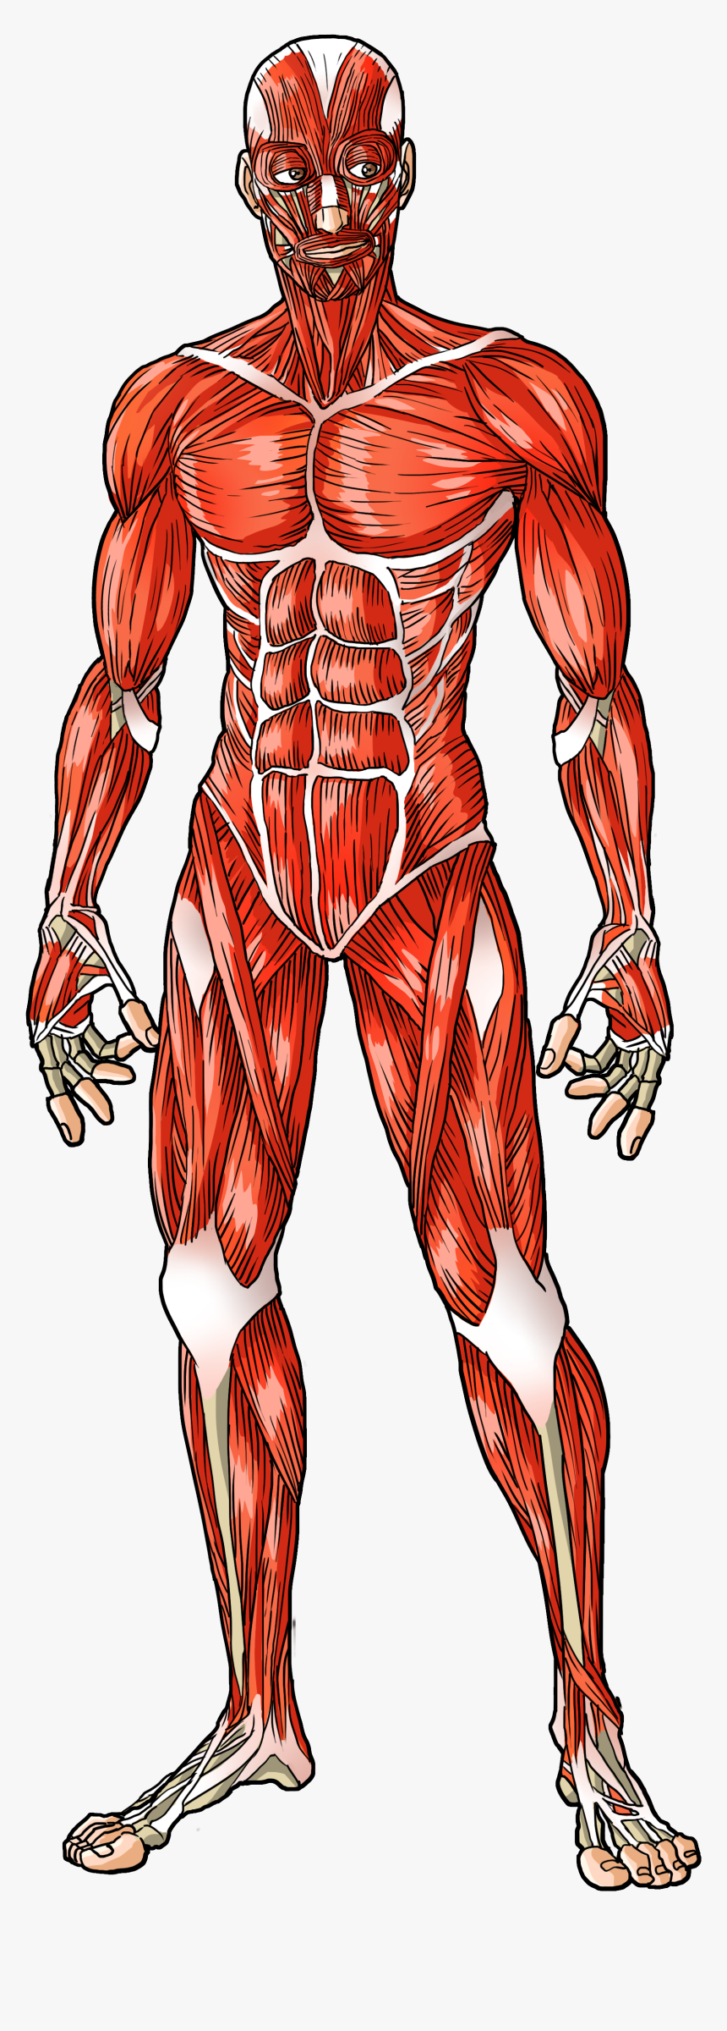
Muscles in the body

