Knowledge Organiser
Year 3: Plants

Key Knowledge: Identify and describe the functions of different parts of flowering plants: roots, stem/trunk, leaves and flowers. Explore the requirements of plants for life and growth (air, light, water, nutrients from soil, and room to grow) and how they vary from plant to plant. Investigate the way in which water is transported within plants. Explore the part that flowers play in the life cycle of flowering plants, including pollination, seed formation and seed dispersal.

Conditions for growth
VOCABULARY
plant- a living thing that usually grows from the ground.
germinate- start of growth.
photosynthesis- plant uses sunlight to make food for the plant.
pollination- flower reproduction.
animal dispersal- seeds transported on animals through being buried, carried on fur, in berries or in poo.
water dispersal- seeds are carried from one place to another in the water.
wind dispersal- seeds are carried from one place to another by wind.
capillary action- water being transported through the plant.

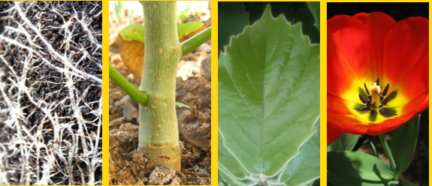
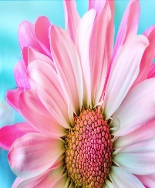
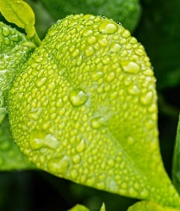
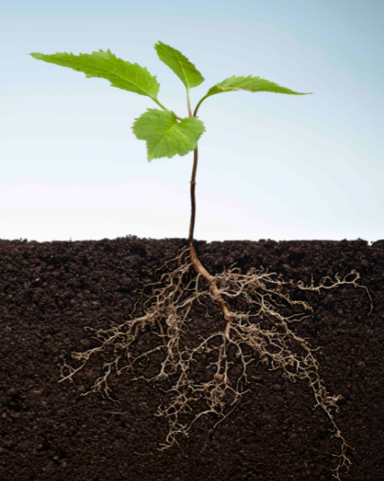
Rain/water
Sunlight
Temperature
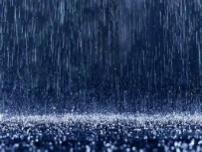
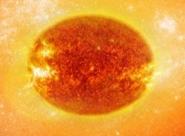
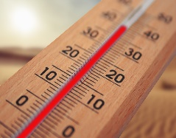
Leaves
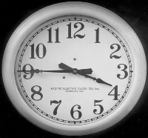
Covered in small hairs.
Anchors plant.
Absorb nutrients and minerals.
Attracts insects.
Helps pollination.
Uses pollen to make new seeds.
POLINATION

Makes food for the plant using sunlight and carbon dioxide from the air.
PHOTOSYNTHESIS.

Hold plant up.
Carries nutrients and minerals from the roots to the leaves.

Stem

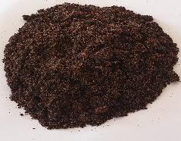

Roots
Air
Time
Nutrients
roots
flower
leaf
stem
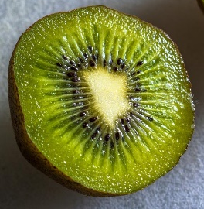
Parts of a flower.
Water, minerals and nutrients transportation.
xylem
stem
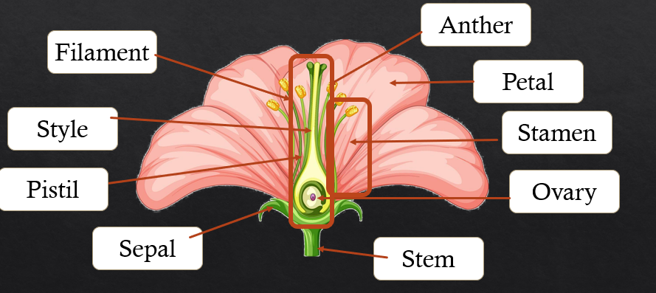
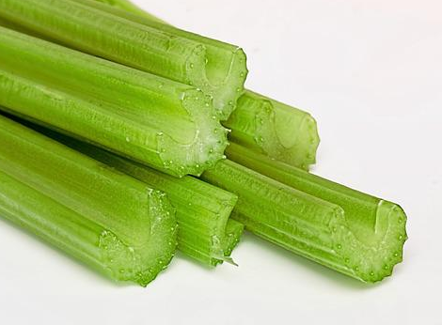
The water is transported through the flower using a process called capillary action. The water transports up the stem to the rest of the flower. The water is needed keep the plant alive and healthy.

Working Scientifically







flower.


Previous Learning: (Year 2) Observe and describe how seeds and bulbs grow into mature plants. Find out and describe how plants need water, light and a suitable temperature to grow and stay healthy.
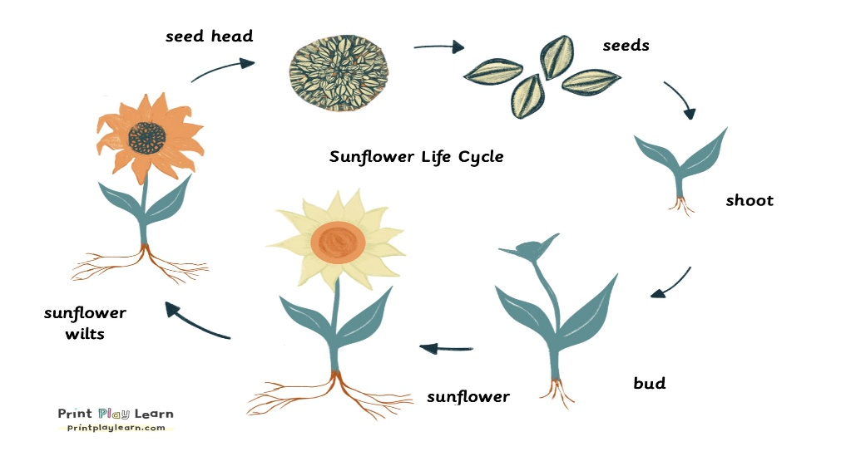
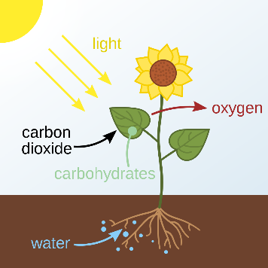
Lifecycle of a sunflower
Photosynthesis
Pollination

Photosynthesis uses sunlight to make food for the plant.
Photosynthesis happens in the leaves of a plant.

The leaves contain chlorophyl, this and light energy help convert carbon dioxide and water into oxygen and glucose- which is food for the plant.

Seed Dispersal

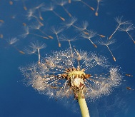
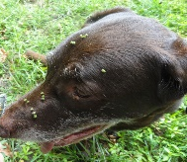
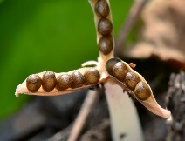
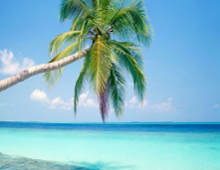
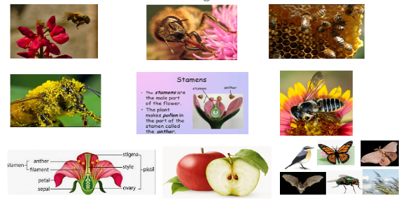
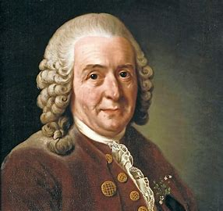
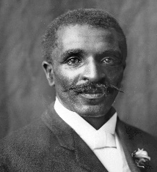
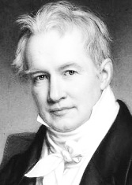
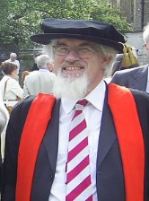






Famous botanists.
Carl
Linnaeus
George Washington Carver
Alexander Von Humboldt
Oliver Rackham
Dr Angie Burnett.
Scientific Enquiry
Pollination happens when an insect carries pollen from the male part of the plant (stamen) to the female part (pistil).
This allows the new plant to make new seeds and fruit.

By animals
By wind
By explosion
By water

