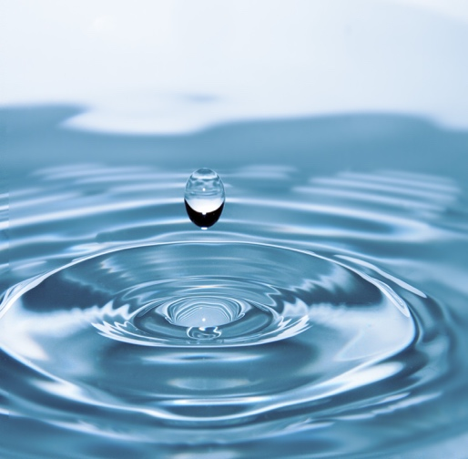

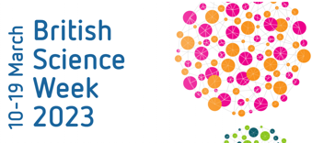

BSW: Why is water so important?
Year 4

Our unit learning intentions | Pupil Self-reflection
LI: To explain the process of how water is cleaned
LI: To identify ways to reduce my water consumption
LI: To observe that some materials change state
LI: To explain how we can support the global water crisis
LI: To use my knowledge to present an argument

Our Scientific Enquiry Skills
  Comparative/Fair testing |   Research |   Observation over time |   Pattern seeking |   Identifying and classifiying
Our Working Scientifically Skills
  Questioning |   Prediction |   Setting up tests |   Observation and measurement |   Recording |   Interpreting results |   Evaluating

water cycle | consumption | global
changing state | condensation | evaporation
precipitation | runoff | transpiration
Vocabulary

