Knowledge Organiser- Year 4
Living Things + Habitats
KEY KNOWLEDGE- Recognise that living things can be grouped in a variety of ways. Explore and use classification keys to help group. Identify and name a variety of living things in the environment. Recognise that environments can change and this can sometimes pose dangers to living things

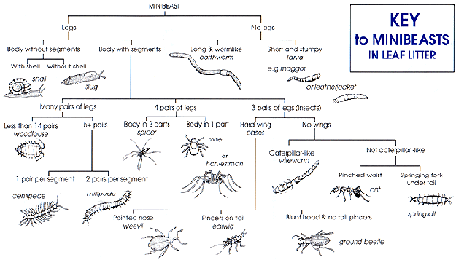
rnnh
What is classification?
Classification keys.
This is the arrangement of things into groups according to their observed similarities.
VOCABULARY
classify- To arrange or group things into categories depending on characteristics.
vertebrate- an animal with a backbone
invertebrate- an animal without a backbone.
cold-blooded- an animal whose body temperature varies with the environment they are in e.g. fish.
warm-blooded- animals that maintain a regular body temperature.
sample- a small amount of something to show what the whole of it may be like..
creature- an animal, distinct from a human being.
habitat- place where an organism makes its home.
hibernate- to become inactive or dormant
migrate- move from one region or habitat to another.
amphibian- cold-blooded vertebrate animal
reptile- vertebrate animal with scaly skin and typically lay soft-shelled eggs on land.
mammal- warm-blooded animal with fur/hair, give birth to live young.
endangered- at risk of extinction.

English naturalist, geologist and biologist, known for his contributions to the science of evolution. He transformed the way we understand the natural world.
He gave us an insight into diversity of life on Earth and its origins.

Invertebrates and Vertebrates

Invertebrates  (Animals without a backbone) | Vertebrates  (Animals with a backbone)
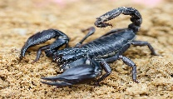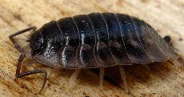  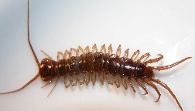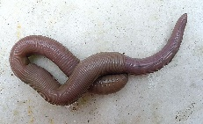 | 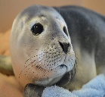

Features of living things.
Movement
Respire (breathe)
Sensitivity to environment
Nutrients
Excrete
Reproduce
Grow



Deciduous and Evergreen


Deciduous  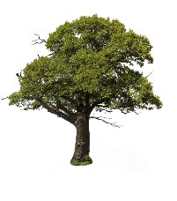(Loses leaves after growing season) | Evergreen  (Stays green all year)
  Maple Oak Elm | 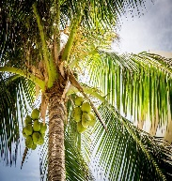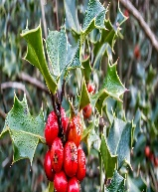  Palm Holly Spruce





Key scientists
WORKING SCIENTIFICALLY: Ask relevant questions.
- Make careful observations and use a range of equipment.
- Gather, record and classify data.
- Record findings using scientific language, drawings, labelled diagrams.
- Identify similarities and differences.
- Use straightforward scientific evidence to answer questions to support findings.

Carl
Linnaeus
1707-1778
Swedish botanist who devised a system for naming organisms.

David Attenborough
1926- present
English broadcaster and naturalist. Best known for his educational tv programmes.




Endangered Animals

Environments change all the time e.g., leaves fall from the trees during Autumn. Sometimes the changes are not expected and have a drastic effect on the living things there.
How changes in environment pose dangers to living things.
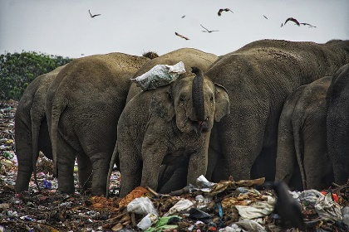
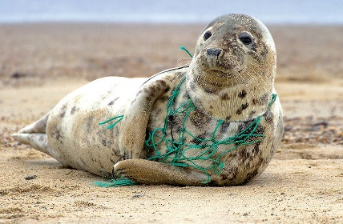
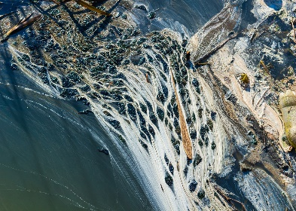
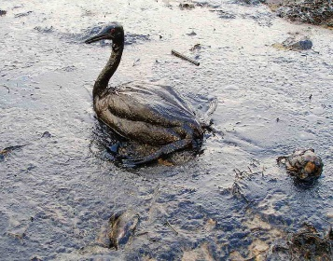
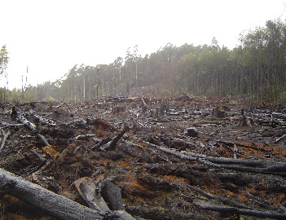
Litter
Oil spill
Deforestation

Plastic pollution
Chemical pollution



There are 41,415 endangered species. 13,306 of them are endangered species threatened with extinction.
10 most endangered species: Giant Panda, Tiger, Whooping crane, Blue whale, Asian Elephant, Sea otter, Snow leopard, Gorilla, Tasmanian Devil, Orangutan



Development
Global warming

