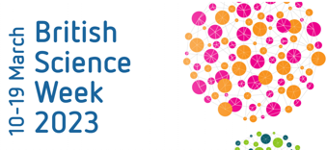

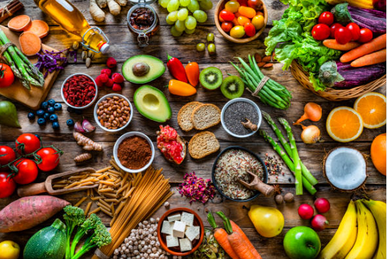
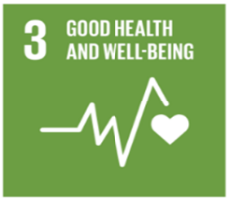

BSW: Good Health and Wellbeing
Year 5

Our unit learning intentions | Pupil Self-reflection
LI: To understand the term ‘food groups’ and ‘balanced diet’.
LI: To recognise the impact of diet, exercise and lifestyle on the way our body’s function.
LI: To understand where food comes from.
LI: To understand the importance of a balanced diet.

Our Scientific Enquiry Skills
  Comparative/Fair testing |   Research |   Observation over time |   Pattern seeking |   Identifying and classifiying
Our Working Scientifically Skills
  Questioning |   Prediction |   Setting up tests |   Observation and measurement |   Recording |   Interpreting results |   Evaluating

Vocabulary
healthy eating | balanced diet | food group | carbohydrate
protein | fat | fibre | nutrients
energy | vitamins | antioxidants | bacteria
immune system | sustainability | fair trade | wellbeing

