Key Knowledge: Describe the changes as humans develop from birth to old age.
-Can explain the changes that take place in boys and girls during puberty
-Can explain how a baby changes physically as it grows and also what it is able to do.
Knowledge Organiser-
Year 5: Animals including Humans



r
The Human lifecycle
VOCABULARY
lifecycle- is the different stages of life for a living thing.
mammal- A warm-blooded vertebrate animal of a class that is distinguished by the possession of hair or fur, females that secrete milk for their young, and typically give birth of live young.
gestation period- foetal development period from the time of conception until birth.
foetus- an unborn or unhatched offspring of a mammal.
puberty- time when the body begins to develop and change as you move from a child to an adult.
reproduction- the production of offspring by a sexual or asexual process.

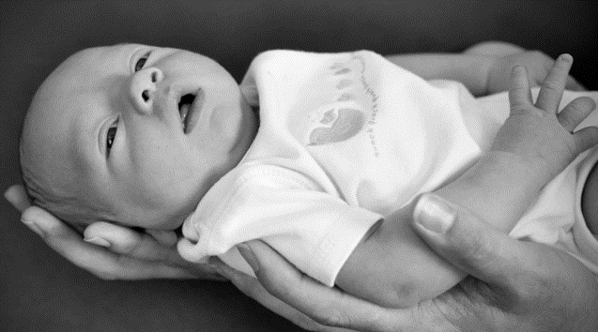
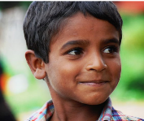

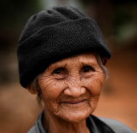

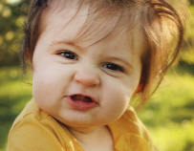

nnh

Foetus Baby Infant/toddler Child Adolescent Young Adult Elderly Death
Teenager Adult

Development of a foetus
Gestation

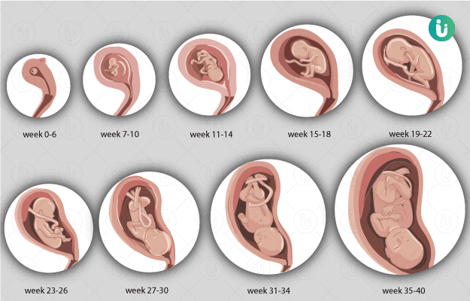
How long their babies take to develop before being born.

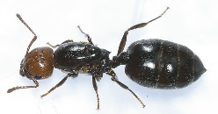
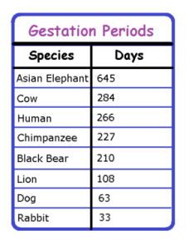
7-7 7-7
7-14 days


150 days

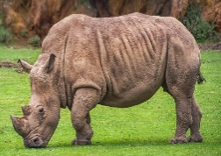
Working Scientifically
420-448
days









Previous Learning (Year 2): Notice that animals, including humans, have offspring which grow into adults.

Science Capital
Puberty

Puberty is when a child’s body begins to develop and change as they become an adult.

Midwives’ role is to look after a pregnant woman and her baby throughout the pregnancy, during labour and birth and for up to 28 days after the baby has been born.

Puberty in boys
Average age for boys to start puberty is 12
It is normal to start puberty from 9 to 14 years.
Changes include:
-Growth spurt, shoulders broaden.
-Voice breaking
-Greasy hair and skin, can cause spots or acne.
-Testicles grow larger.
-Hair under arms, on face and between legs
-Sweat more.

Puberty in girls
Average age for girls to start puberty is 11.
It is normal start puberty between 8 and 13 years.
Changes include:
-Growth spurt
-Breasts develop and grow
-Hair under arm and between legs
-Greasy hair and skin, can cause spots or acne.
-Periods start.
-Sweat more

Mental Health

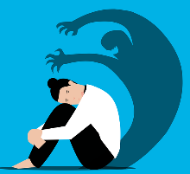
We must look after our mental health. A healthy
mind is as important as a healthy body.

We can look after our mental health by:

-Eating well, drinking water, doing activities we enjoy, sleeping well, having good friends, working towards our goals, talking to people we trust about how we feel.

We can help each other by:

Talking Listening Telling


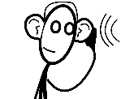





Scientific Enquiry

