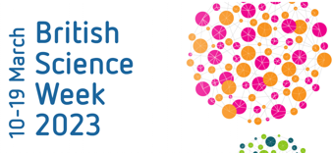
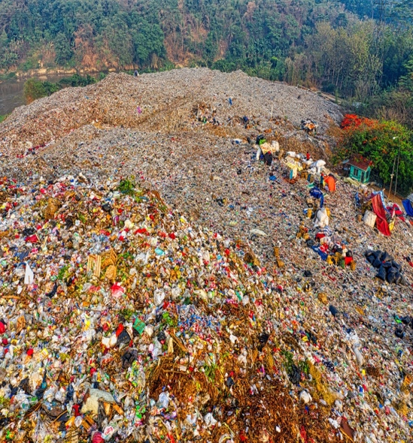


BSW: Affordable and clean energy
Year 6

Our unit learning intentions | Pupil Self-reflection
LI: To understand the terms Watts and Amps.
LI: To compare and give reasons for variations in how components function- linked to sustainable energy.

Our Scientific Enquiry Skills
  Comparative/Fair testing |   Research |   Observation over time |   Pattern seeking |   Identifying and classifiying

Our Working Scientifically Skills
  Questioning |   Prediction |   Setting up tests |   Observation and measurement |   Recording |   Interpreting results |   Evaluating

Key Vocabulary

renewable | sustainable | watt | amp
voltage | solar | biomass | turbine
hydropower | electricity | energy | movement
heat | tidal/wave | circuit | sound

