Knowledge Organiser Year 6: Light
Key Knowledge: To describe with diagrams how light travels in straight lines, either from sources or reflected from other objects into our eyes. To describe with diagrams how light travels in straight lines past translucent or opaque objects to form a shadow of the same shape

rnnh
Light
Reflection
Prism
VOCABULARY

light- Light is a type of energy that makes it possible for us to see.
source of light- The sun and other stars, fires, torches and lamps all make light are examples of light sources.
reflection- Reflection occurs when a light ray hits a surface and bounces off.
visible spectrum- The range of colours we can see with our eyes.
prism- A prism is a 3d shape with identical ends, called bases and flat sides called faces. A prism allows us to see the visible spectrum.
shadow- A dark area of shape produced by an object coming between rays of light and a surface.
opaque- An opaque material does not let light through. It does not reflect light.
translucent- A translucent material lets light pass through, but objects on the other side cant be seen clearly.
transparent- Transparent materials allow you to see clearly through them.
refraction- Light changes direction when passing through two different mediums.

Light is a form of energy that enables us to see.

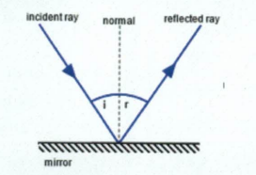
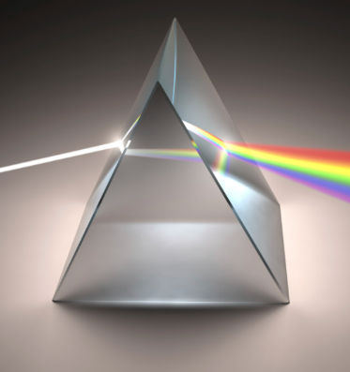
Light travels in straight lines. It reflects off mirrors according to the law of reflection which states that the angle of incidence (i) = angle of reflection (r).

Light appears colourless (or white), when produced by natural light sources such as the sun or artificial light sources such as light bulbs or torches. White light is made up of a spectrum of colours with different wavelengths: red, orange, yellow, green, blue, indigo and violet.

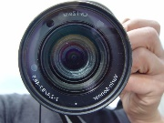
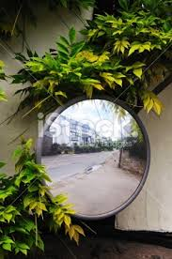
Periscopes
Mirrors in real life.

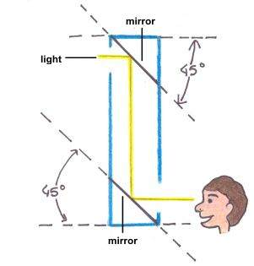
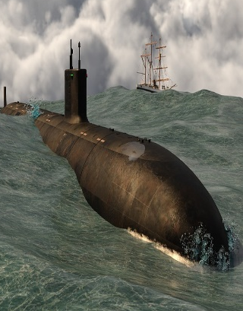
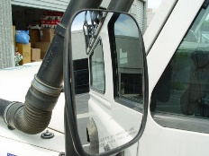
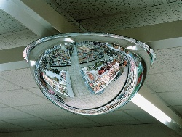
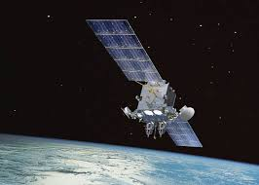
Light from an object strikes the top mirror at 45 and bounces off at the same angle. This sends light directly down the tube and onto the lower mirror. This mirror is also at 45 degrees which reflects light into your eye.

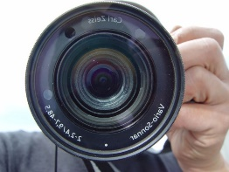
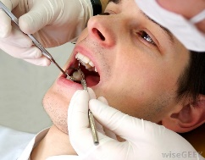
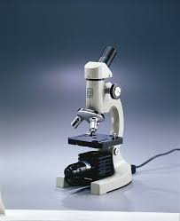

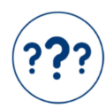



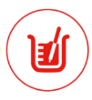

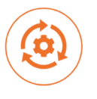

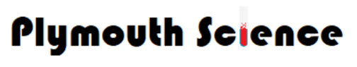
Working Scientifically: ♣ Taking measurements, using a range of scientific equipment, with increasing accuracy and precision, taking repeat readings when appropriate ♣ Recording data and results of increasing complexity using scientific diagrams and labels. ♣ Use test results to make predictions to set up further comparative and fair tests ♣ Report and present findings from enquiries, including conclusions, causal relationships and explanations of and degree of trust in results, in oral and written forms such as displays and other presentations

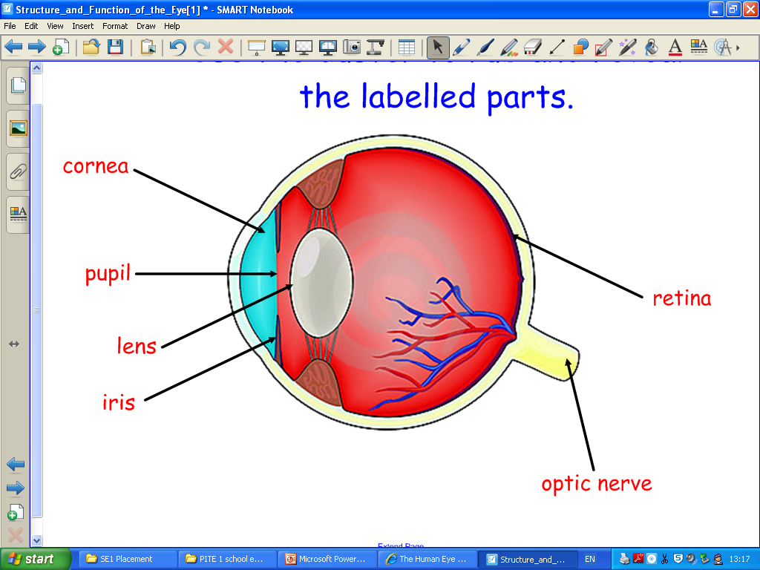
The Eye
The little dark circle in the centre of each eye lets light in. It is called the pupil.
When you turn the light on from a dark room your pupil will dilate (get smaller)

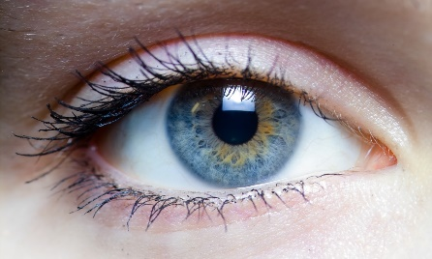
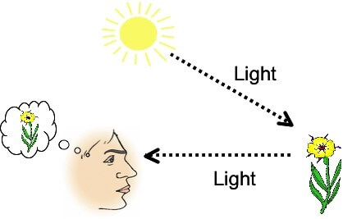
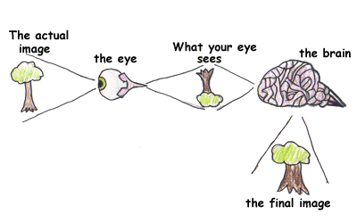
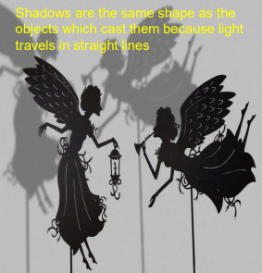
How do we see?
Light travels in straight lines. When light hits an object, it is reflected (bounces off) and enters our eye. This is how we see the object.
Refraction
Refraction is the change in the direction of a wave passing from one medium to another.
Refraction makes it possible for us to have optical instruments such as magnifying glasses, lenses and prisms.
Shadow
When an object passes in front of a beam of light, the light can be blocked making a shadow. Opaque objects let no light through. Translucent objects let some light through, and transparent objects let all the light through. The closer an object is to the light source the bigger the shadow.

