Key Knowledge: Describe how living things are classified into broad groups according to common observable characteristics and based on similarities and differences, including micro-organisms, plants and animals.
Give reasons for classifying plants and animals based on specific characteristics

Knowledge Organiser
Year 6- Living things +
habitats

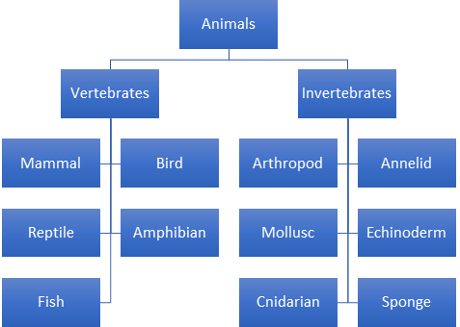
rnnh
Classification
Science Capital (Scientists)
VOCABULARY
organism- An organic living system composed of cells.
microorganism- organism of microscopic size.
fungus- part of Fungi kingdom includes yeast, rust, molds and mushrooms.
bacteria- small single cell organisms fvund everywhere on earth.
virus- microscopic parasites generally smaller than bacteria.
fish- aquatic gill bearing animals
amphibian- cold blooded vertebrate animal.
insect- small arthropod animal which has 6 legs and generally one or two pairs of wings.
reptile- a vertebrate animal typically with dry scaly skin and lay soft shelled eggs on land.
bird- warm blooded egg laying vertebrate animal with feathers, wings and a beak.
arachnid- an arthropod e.g. spiders and scorpions.
mollusc- an invertebrate including snails, slugs, mussels and octopuses.
vertebrate- animal with backbone
invertebrate- animal without backbone.
classification- To make smaller groups.

Aristotle
384BC – 322BC
Aristotle was the first person to try and classify
living things
into groups.

Carl Linnaeus
1707- 1778
Carl Linnaeus was a Swedish scientist who believed
it was a very
important to have a
standard system of classification.

The Seven Level of Linnaeus’ System

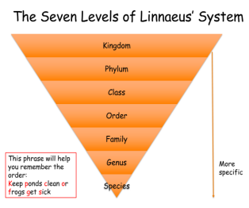
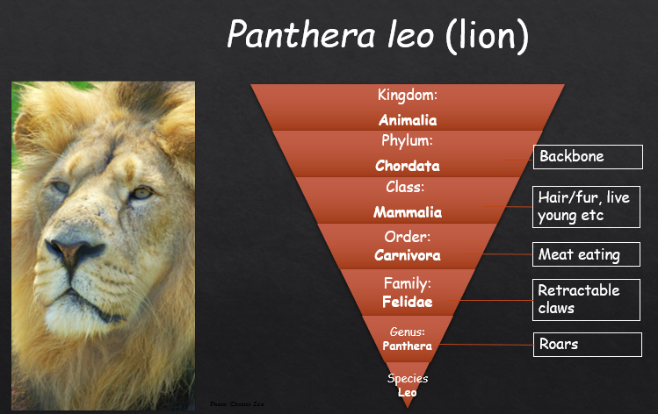








Working Scientifically
Taxonomy
Prior Learning (Year4) : Recognise that living things can be grouped in a variety of ways. Explore and use classification keys to help group, identify and name a variety of living things in their local environment.

Mammals
(Phylum Chordata, Class mammalia)

Birds
(Phylum Chordata, Class aves)
Reptiles
(Phylum Chordata, Class reptilia)
Amphibians
(Phylum Chordata, Class Lissamphibia)
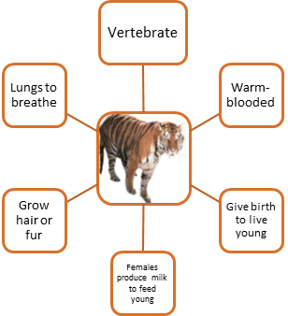
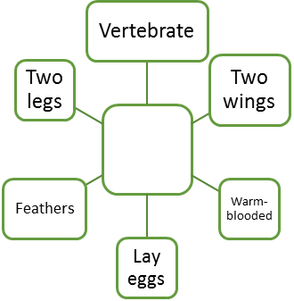
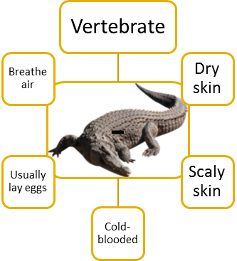
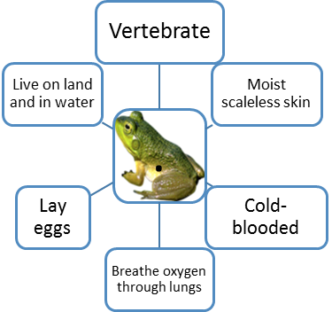

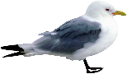

Fish
(Phylum Chordata, Class Osteichthyes)
Cartilaginous Fish
(Phylum Chordata, Class Chondrichthyes)
Invertebrates
Microbes



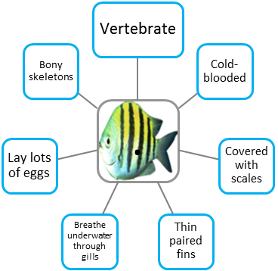
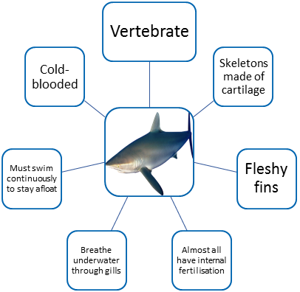
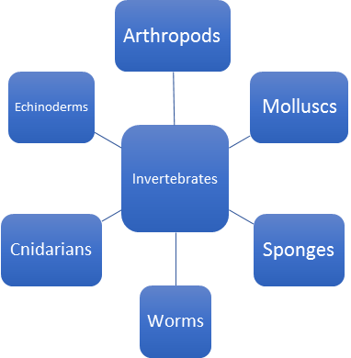
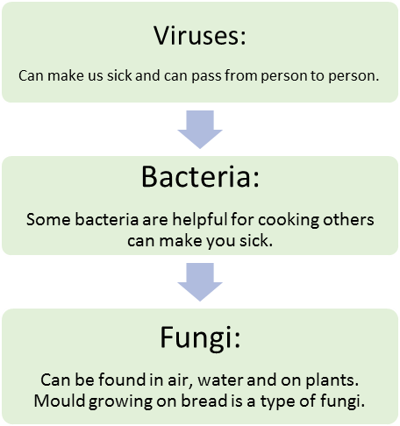
Famous Scientists:
Edward Jenner: discovery of smallpox
Alexander Fleming: penicillin.
Scientific Enquiry

